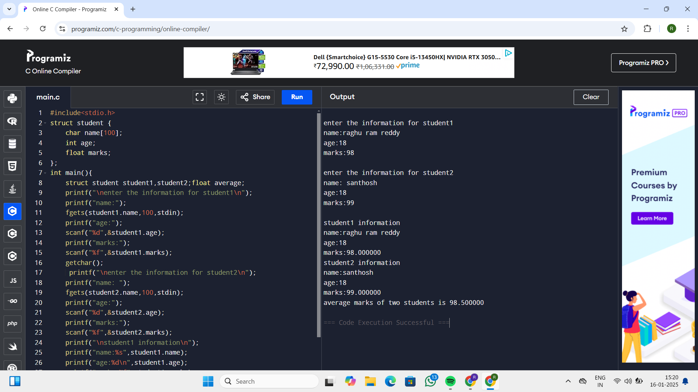 1) #include<stdio.h>

struct student {

char name[100];

int age;

float marks;

};

int main(){

struct student student1,student2;float average;

printf("\nenter the information for student1\n");

printf("name:");

fgets(student1.name,100,stdin);

printf("age:");

scanf("%d",&student1.age);

printf("marks:");

scanf("%f",&student1.marks);

getchar();

printf("\nenter the information for student2\n");

printf("name: ");

fgets(student2.name,100,stdin);

printf("age:");

scanf("%d",&student2.age);

printf("marks:");

scanf("%f",&student2.marks);

printf("\nstudent1 information\n");

printf("name:%s",student1.name);

printf("age:%d\n",student1.age);

printf("marks:%f",student1.marks);

printf("\nstudent2 information\n");

printf("name:%s",student2.name);

printf("age:%d\n",student2.age);

printf("marks:%f\n",student2.marks);

average=(student1.marks+student2.marks)/2;

printf("average marks of two students is %f",average);

return 0;

}

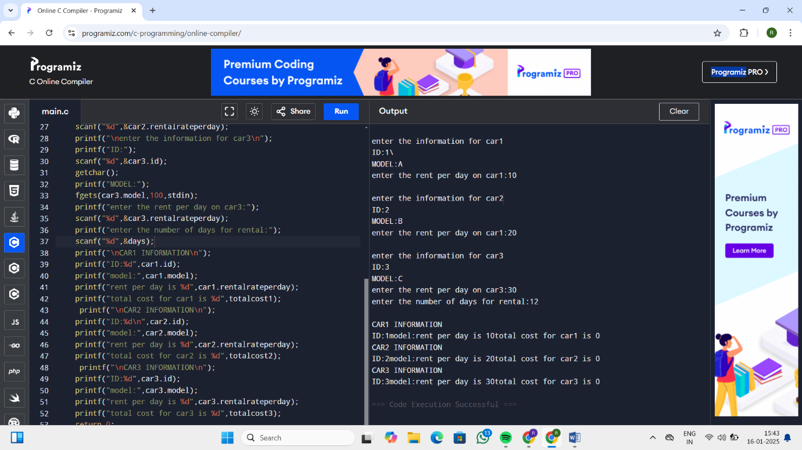

2) #include<stdio.h>

struct car{

int id;

char model[100];

int rentalrateperday;

};

int main(){

struct car car1,car2,car3;int days;

int totalcost1=car1.rentalrateperday\*days;

int totalcost2=car2.rentalrateperday\*days;

int totalcost3=car3.rentalrateperday\*days;

printf("\nenter the information for car1\n");

printf("ID:");

scanf("%d",&car1.id);

getchar();

printf("MODEL:");

fgets(car1.model,100,stdin);

printf("enter the rent per day on car1:");

scanf("%d",&car1.rentalrateperday);

printf("\nenter the information for car2\n");

printf("ID:");

scanf("%d",&car2.id);

getchar();

printf("MODEL:");

fgets(car2.model,100,stdin);

printf("enter the rent per day on car1:");

scanf("%d",&car2.rentalrateperday);

printf("\nenter the information for car3\n");

printf("ID:");

scanf("%d",&car3.id);

getchar();

printf("MODEL:");

fgets(car3.model,100,stdin);

printf("enter the rent per day on car3:");

scanf("%d",&car3.rentalrateperday);

printf("enter the number of days for rental:");

scanf("%d",&days);

printf("\nCAR1 INFORMATION\n");

printf("ID:%d",car1.id);

printf("model:",car1.model);

printf("rent per day is %d",car1.rentalrateperday);

printf("total cost for car1 is %d",totalcost1);

printf("\nCAR2 INFORMATION\n");

printf("ID:%d\n",car2.id);

printf("model:",car2.model);

printf("rent per day is %d",car2.rentalrateperday);

printf("total cost for car2 is %d",totalcost2);

printf("\nCAR3 INFORMATION\n");

printf("ID:%d",car3.id);

printf("model:",car3.model);

printf("rent per day is %d",car3.rentalrateperday);

printf("total cost for car3 is %d",totalcost3);

return 0;

}

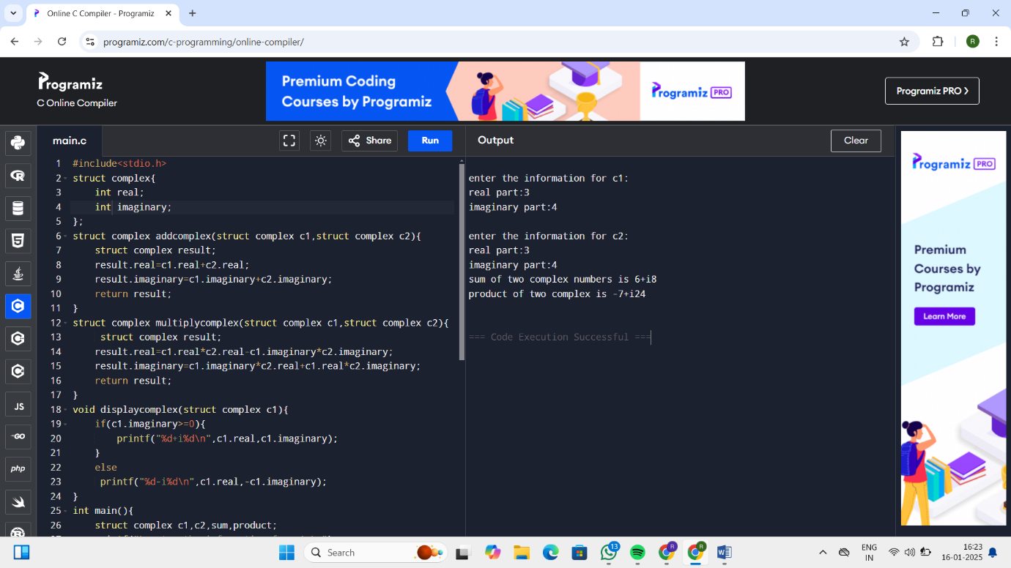

3)

#include<stdio.h>

struct complex{

int real;

int imaginary;

};

struct complex addcomplex(struct complex c1,struct complex c2){

struct complex result;

result.real=c1.real+c2.real;

result.imaginary=c1.imaginary+c2.imaginary;

return result;

}

struct complex multiplycomplex(struct complex c1,struct complex c2){

struct complex result;

result.real=c1.real\*c2.real-c1.imaginary\*c2.imaginary;

result.imaginary=c1.imaginary\*c2.real+c1.real\*c2.imaginary;

return result;

}

void displaycomplex(struct complex c1){

if(c1.imaginary>=0){

printf("%d+i%d\n",c1.real,c1.imaginary);

}

else

printf("%d-i%d\n",c1.real,-c1.imaginary);

}

int main(){

struct complex c1,c2,sum,product;

printf("\nenter the information for c1:\n");

printf("real part:");

scanf("%d",&c1.real);

printf("imaginary part:");

scanf("%d",&c1.imaginary);

printf("\nenter the information for c2:\n");

printf("real part:");

scanf("%d",&c2.real);

printf("imaginary part:");

scanf("%d",&c2.imaginary);

sum=addcomplex(c1,c2);

printf("sum of two complex numbers is ");

displaycomplex(sum);

product=multiplycomplex(c1,c2);

printf("product of two complex is ");

displaycomplex(product);

return 0;

}

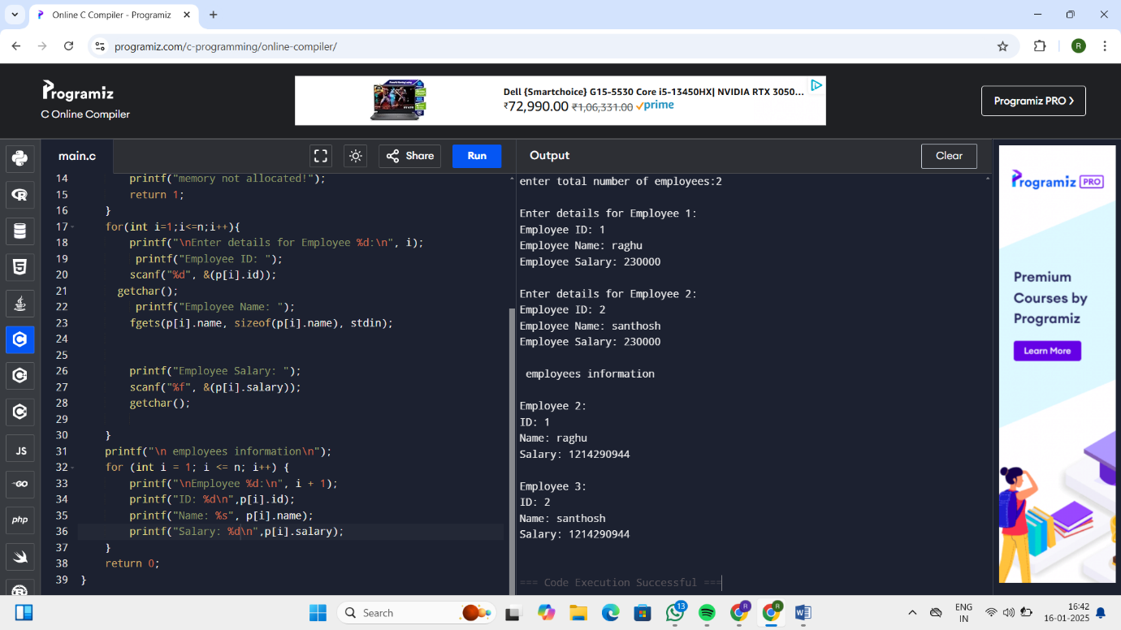

4) #include<stdio.h>

#include<stdlib.h>

struct employee{

char name[100];

int id;

int salary;

};

int main(){

int n;

printf("enter total number of employees:");

scanf("%d",&n);

struct employee \*p=(struct employee\*)malloc(n\*sizeof(struct employee));

if(p==NULL){

printf("memory not allocated!");

return 1;

}

for(int i=1;i<=n;i++){

printf("\nEnter details for Employee %d:\n", i);

printf("Employee ID: ");

scanf("%d", &(p[i].id));

getchar();

printf("Employee Name: ");

fgets(p[i].name, sizeof(p[i].name), stdin);

printf("Employee Salary: ");

scanf("%f", &(p[i].salary));

getchar();

}

printf("\n employees information\n");

for (int i = 1; i <= n; i++) {

printf("\nEmployee %d:\n", i + 1);

printf("ID: %d\n",p[i].id);

printf("Name: %s", p[i].name);

printf("Salary: %d\n",p[i].salary);

}

return 0;

}